Past Simple and Continuous
Put the verbs into the correct form, Past Progressive Tense or Past Simple Tense.
1. When I (phone) _______________________ my friends, they (play) ______________________ monopoly.
2. The kids (play) ___________________ in the garden when it (suddenly, begin) ________________ to rain.
3. While Minnie (work) __________________ in his room, his friends (swim) ____________________ in the pool.
4. Jane (wait) ___________________ for his sister when he (see) ___________________ the most beautiful girl.
5. When we (take out) ___________________ the garbage, it (get) ___________________ dark.
6. The wife (put on) ___________________make-up while the husband (polish) ___________________ his shoes.
7. A: What (you/do) ___________________ when these people arrived?
8. Nobody (listen) ___________________ while the teacher (explain) ___________________ the tenses.
9. I (sit) ___________________ down to dinner, so I (not answer) ___________________ your call.
10. I (practice) ___________________ the guitar when he (come) ___________________ home.
11. While we (do) ___________________a sight-seeing tour, our friends (lie) ___________________ on the beach.
12. She (fill) ___________________ in a questionnaire when the pen (run) ___________________ out of ink.
13. When we last (see) ___________________ him, he (still wear) ___________________ his gym clothes.
14. Her parents (dance) ____________________ at the ball when the burglar (break) _____________ into their house.
15. Every day James Lullaby travels to London. Yesterday he (drive) ___________________ his car when he (see)
___________________ a dog in the middle of the road. The dog (watch) ___________________the car.
James (stop) ___________________ and (get) ___________________ out of his car. As he (get)
___________________ out, the dog (run) ___________________ away. James (go) ___________________ back
to his car. While he (get) ___________________ in it, the dog (appear) ___________________ again and
(sit) ___________________ down in the middle of the road. James (start) ___________________ the engine,
but the dog (not move) ___________________. James (jump) ___________________ out of the car and
(shout) ___________________ at the dog. The dog (bark) ___________________at him and
(start) ___________________ to run. James (follow) ___________________ the dog. Suddenly, he (see)
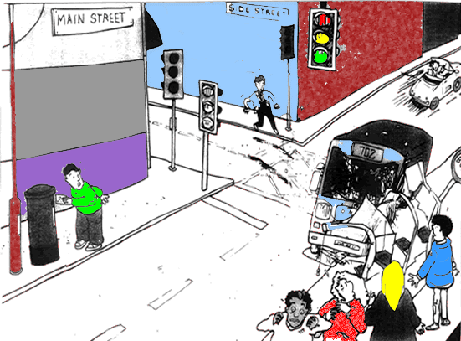
___________________ two girls lying on the grass. They (bleed) ___________________.
16. I (go) _________________to post a letter when I (hear) __________________a loud bang across the street.

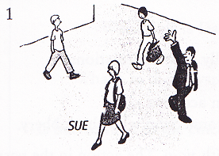
17. I (see) ______________ Sue in town yesterday, but she (not see) ________________ me. She (look) ______________ the other way.

18. I (meet) ______________ Tom and Jane at the airport a few weeks ago. They (go) ______________ to Paris and I (go) _______________ to Rome We (have) ________________ a chat while we (wait) _________________ for our flights.

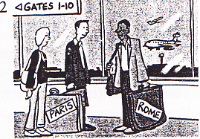

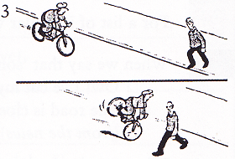
19. I (cycle) _________________ home yesterday when a man (step) ________________________ out into the road in front of me. I (go) _______________ quite fast, but luckily I (manage) __________________ to stop in time and (not hit) _________________ him.

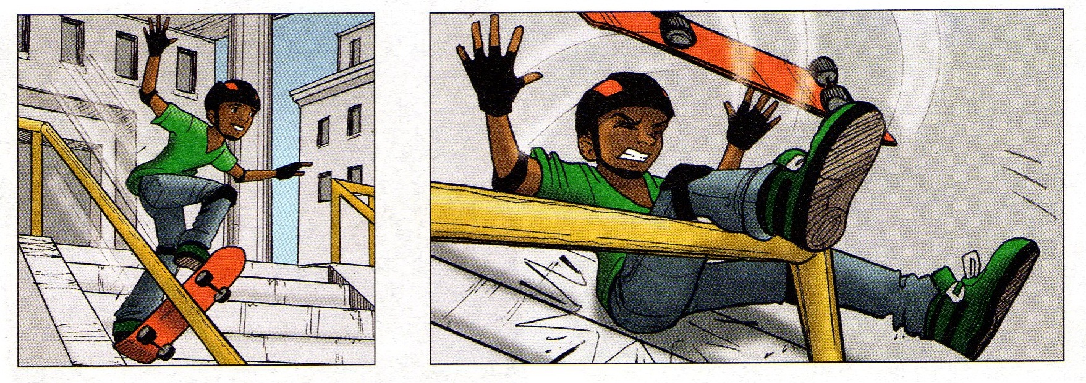
20. Shawn (jump) ____________________ on his skateboard when he (fall off) ____________________.

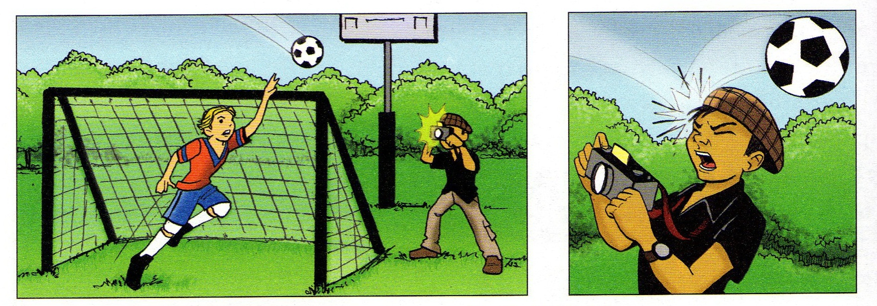
21. The photographer (take) ______________________ photos when the ball (hit) __________________him.

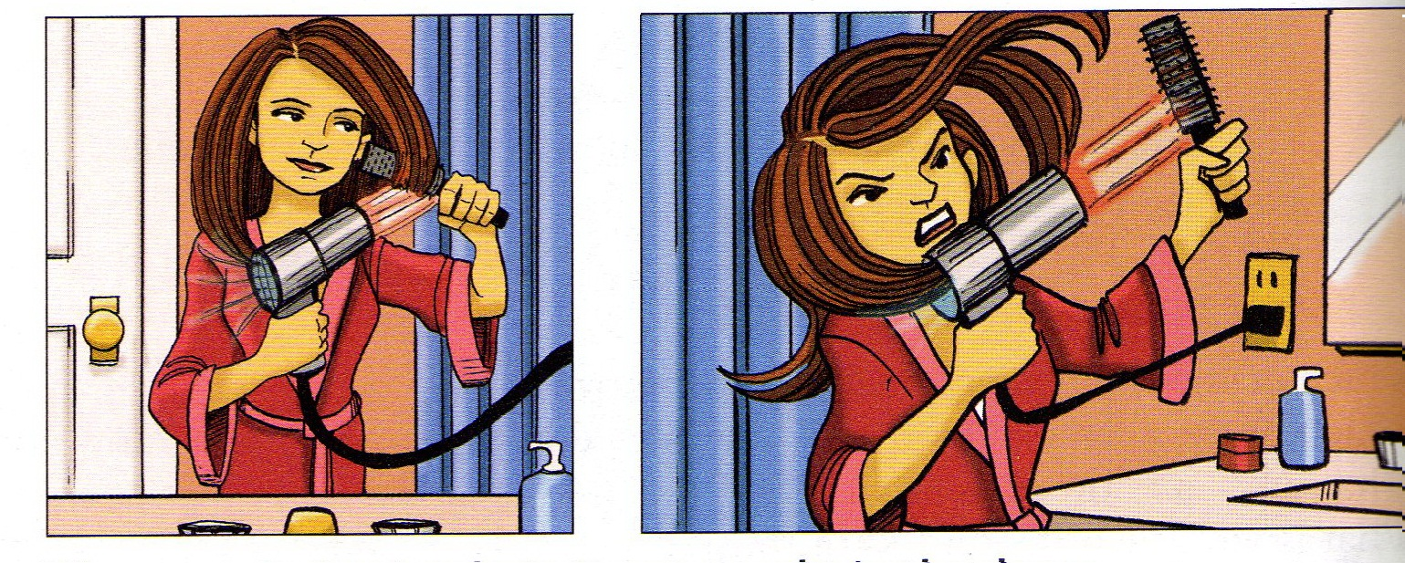

22. Eliza (dry) _____________________ her hair when it (get) ______________________ caught in the dryer.

